

Dear Parents/Guardians

Sign of the week for this term– starting week beginning 18th January

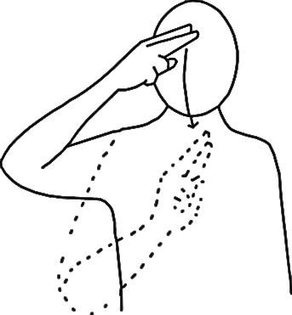

Name

15th January

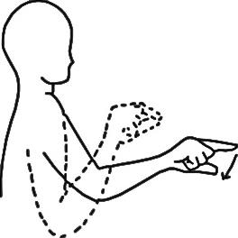

Choose

22nd January

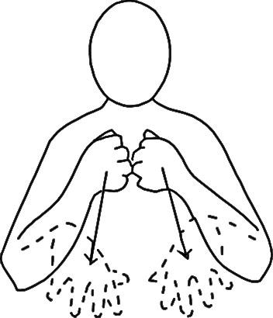

Finish

29th January



Again

5th February

Please practice these at home

Many thanks

Charlotte Cooke

Regional Makaton Tutor