

Dear Parent/Guardian.

Sign of the week for this term– starting week beginning 16th April.

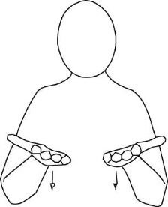

now

16th April



next

23rd April

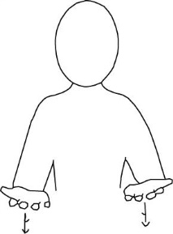

today

30th April



Time

7th May



14th May

before



After/later

21st May

Please practice these at home

Many thanks

Charlotte Cooke

Regional Makaton Tutor